NEW YORK (AP) -- The economy is melting -- literally.
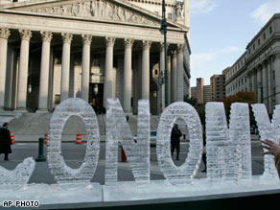
“THE MAIN STREET MELTDOWN”

Artists say an ice sculpture is a literal representation of the nation's financial crisis.
On Wednesday, October 29, 2008 two artists, Nora Ligorano and Marshall Reese installed a 1,500-pound ice sculpture that spelled the word "Economy" in Manhattan's financial district. The artists said the sculpture, which stood 5 feet tall, 15 feet wide and sat on a pedestal, was installed on Oct. 29 because it was the 79th anniversary of the day in 1929 when the stock market crashed, precipitating the Great Depression.
The "Main Street Meltdown" was to remain in Foley Square until it melted -- about 24 hours. By Wednesday evening, the E and the C had already thawed and vanished. The backdrop to the sculpture is the wide stairs and row of pillars fronting the state Supreme Court building.

