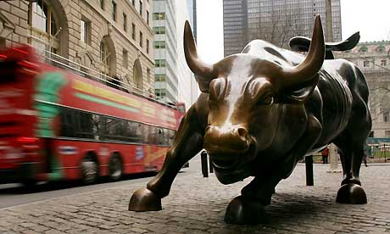
SYMBOL OF WALL STREET

