The New York Stock Exchange Bell

The Bell
One of the most familiar features of the New York Stock Exchange is the loud, distinctive Trading Floor bell. "THE OPENING BELLSM" signals the beginning of trading each business day and "THE CLOSING BELL®" signals the ending of trading each business day.  Bells were introduced when continuous trading was instituted in the 1870s. Originally, a Chinese Gong was used, but brass bells have been used since The Exchange moved to its current location in 1903.  There is one large bell in each of the four trading areas of the NYSE. The bells are operated synchronously from a single control. | 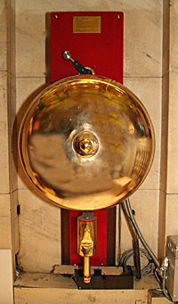  Click the picture to hear "The Bell®."  (87K wav

